SYSTEM ANALYSIS AND

DESIGN

UNIT – 1

System Study and System Development Life Cycle

Shree M. & N. Virani Science College (Autonomous)

ATMIYA Group of Institutions, Yogidham Gurukul, Rajkot.

Priyank Doshi

Asst. Professor (MCA, MSc.(Math) )



Fact Finding Techniques

.

.

.

Record review

Observing the current system

Questionnaires

.

Questions can follow four formats:

.

.

.

.

Multiple choices

Open ended

Rating

Ranking

.

Interviewing

.

.

Formal Vs. Informal

Primary Vs. Detailed

Shree M. & N. Virani Science College (Autonomous)

ATMIYA Group of Institutions, Yogidham Gurukul, Rajkot.

Priyank Doshi

Asst. Professor (MCA, MSc.(Math) )



The following questions can help accomplish

this goal.

.

.

.

.

.

.

.

Who is involved with what you do?

What do you do?

Where do you do it?

When do you do it?

Why do you do it the way you do?

How do you do it?

Do you have suggestions for change?

Shree M. & N. Virani Science College (Autonomous)

ATMIYA Group of Institutions, Yogidham Gurukul, Rajkot.

Priyank Doshi

Asst. Professor (MCA, MSc.(Math) )



UML

.

The Unified Modeling Language (UML) is a standard language

for specifying, visualizing, constructing, and documenting the

piece of software systems, as well as for business modeling and

other non-software systems.

.

The UML uses mostly graphical notations to express the design

of software projects. Using the UML helps project teams

communicate, explore potential designs, and validate the

architectural design of the software.

Shree M. & N. Virani Science College (Autonomous)

ATMIYA Group of Institutions, Yogidham Gurukul, Rajkot.

Priyank Doshi

Asst. Professor (MCA, MSc.(Math) )



Goals of UML

.

.

.

Provide users with a ready-to-use, expressive visual modeling language so they

can develop and exchange meaningful models.

Provide extensibility and specialization mechanisms to extend the core

concepts.

Be independent of particular programming languages and development

processes.

.

.

.

Provide a formal basis for understanding the modeling language.

Encourage the growth of the OO tools market.

Support higher-level development concepts such as collaborations, frameworks,

patterns and components.

.

Integrate best practices.

Shree M. & N. Virani Science College (Autonomous)

ATMIYA Group of Institutions, Yogidham Gurukul, Rajkot.

Priyank Doshi

Asst. Professor (MCA, MSc.(Math) )



Class Diagram

.

Classes are composed of three things: a name, attributes, and

operations. Below is an example of a class.

Class name

Attributes

Operations

Shree M. & N. Virani Science College (Autonomous)

ATMIYA Group of Institutions, Yogidham Gurukul, Rajkot.

Priyank Doshi

Asst. Professor (MCA, MSc.(Math) )

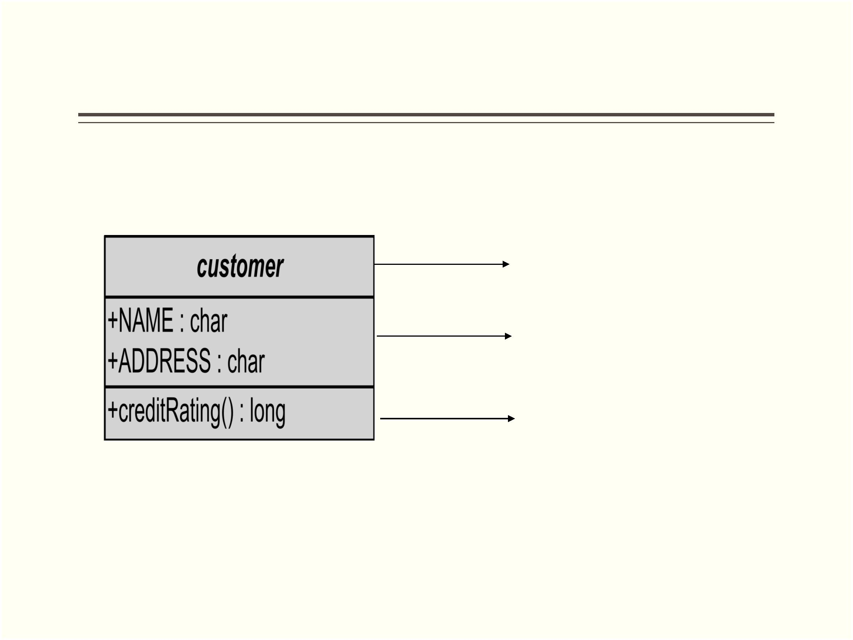

Class diagrams also display relationships such as

containment, inheritance and associations.

**Relation Type : Association**

Shree M. & N. Virani Science College (Autonomous)

Priyank Doshi

Asst. Professor (MCA, MSc.(Math) )

ATMIYA Group of Institutions, Yogidham Gurukul, Rajkot.

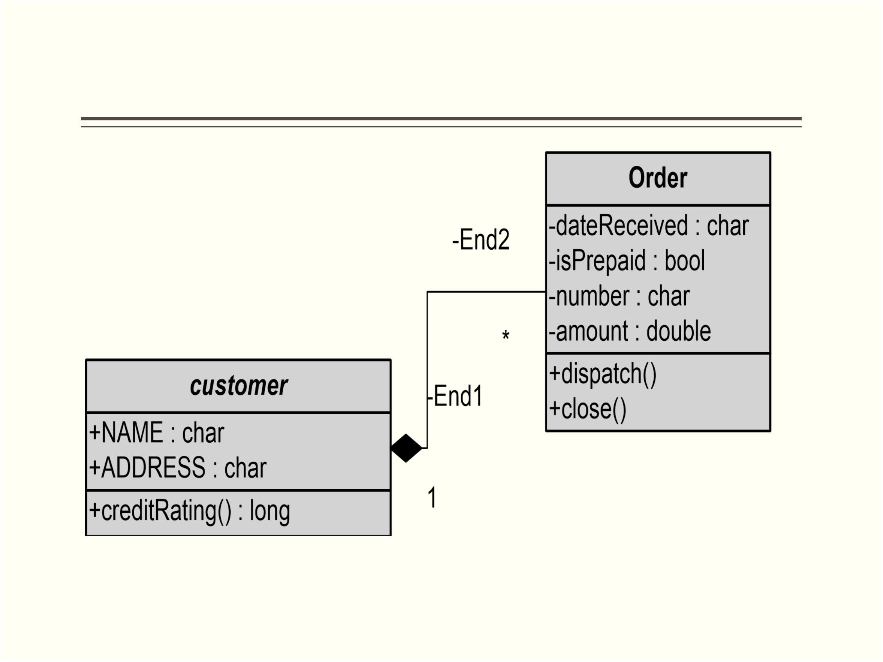

**Inheritance**

Shree M. & N. Virani Science College (Autonomous)

ATMIYA Group of Institutions, Yogidham Gurukul, Rajkot.

Priyank Doshi

Asst. Professor (MCA, MSc.(Math) )

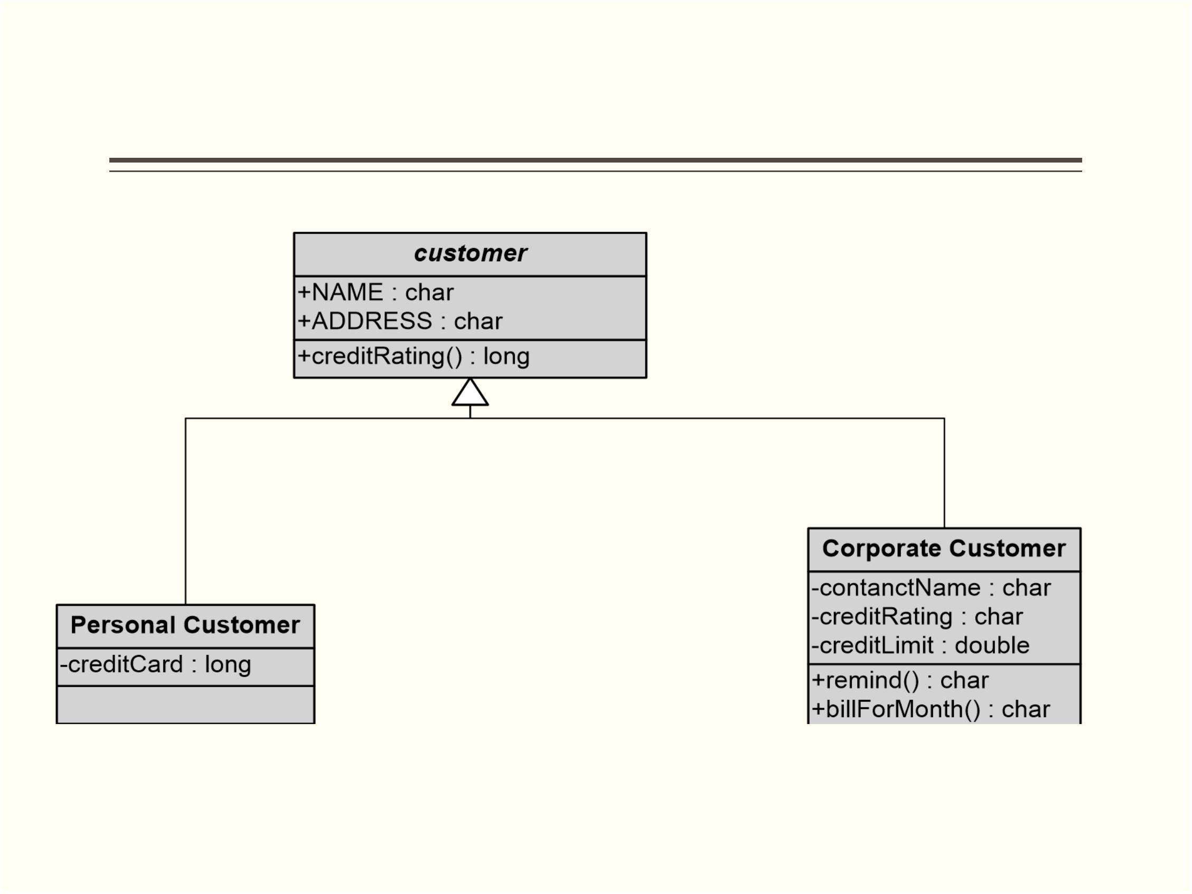

Class Diagram

(All classes are connected to each other)

Shree M. & N. Virani Science College (Autonomous)

Priyank Doshi

Asst. Professor (MCA, MSc.(Math) )

ATMIYA Group of Institutions, Yogidham Gurukul, Rajkot.

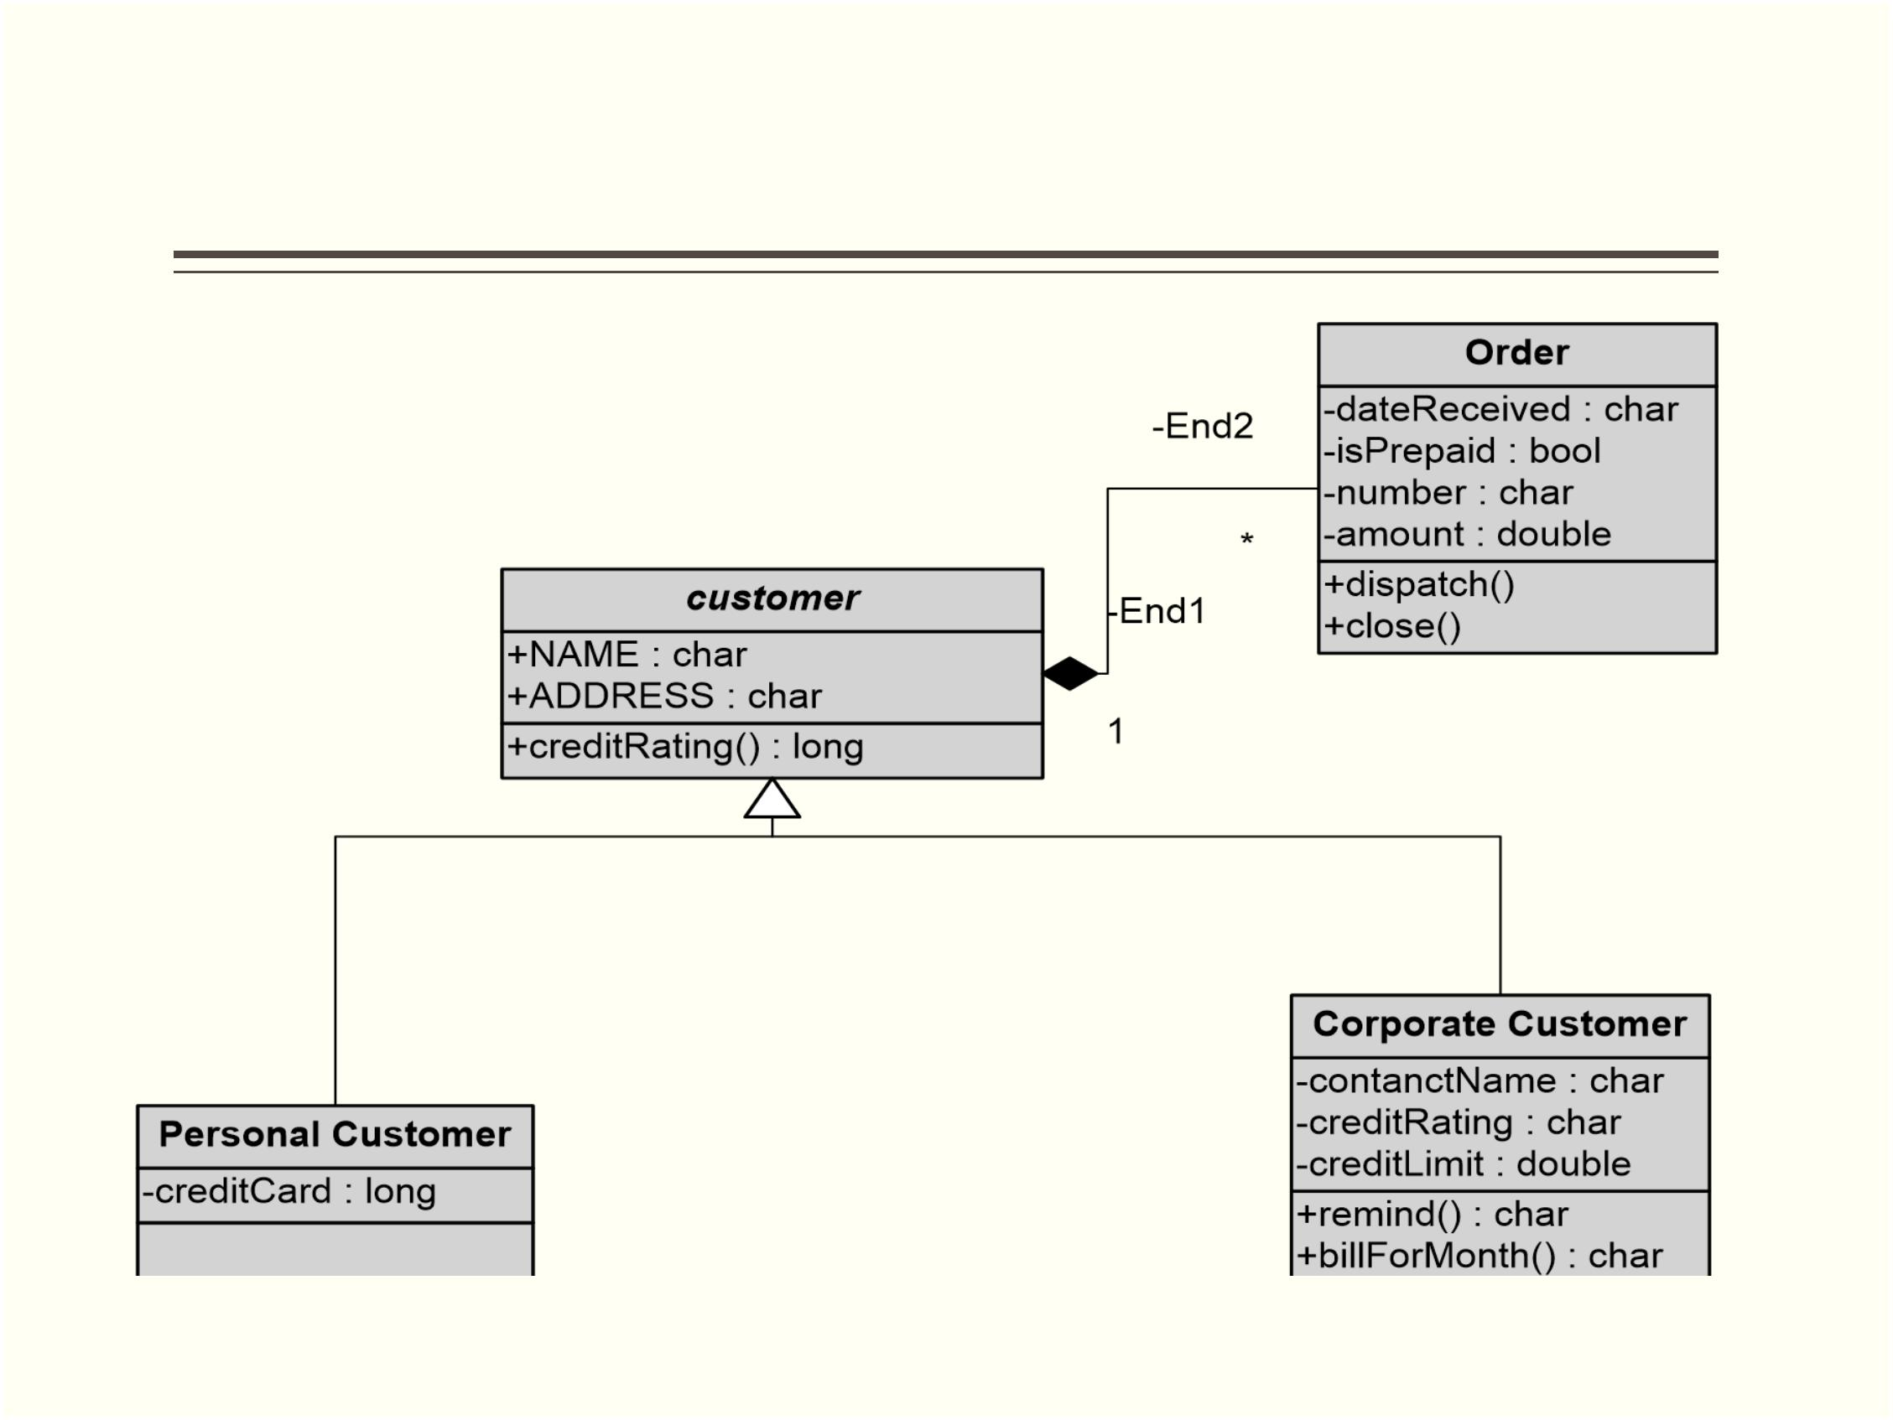

Use Case Diagram

.

.

.

.

Use case is a set of scenarios that describing an interaction

between a user and a system.

The two main components of a use case diagram are use cases

and actors.

A use case diagram displays the relationship among actors and use

cases.

An actor is represents a user. A use case is an external view of the

system that represents some action the user might perform in order

to complete a task.

Shree M. & N. Virani Science College (Autonomous)

ATMIYA Group of Institutions, Yogidham Gurukul, Rajkot.

Priyank Doshi

Asst. Professor (MCA, MSc.(Math) )



Shree M. & N. Virani Science College (Autonomous)

ATMIYA Group of Institutions, Yogidham Gurukul, Rajkot.

Priyank Doshi

Asst. Professor (MCA, MSc.(Math) )

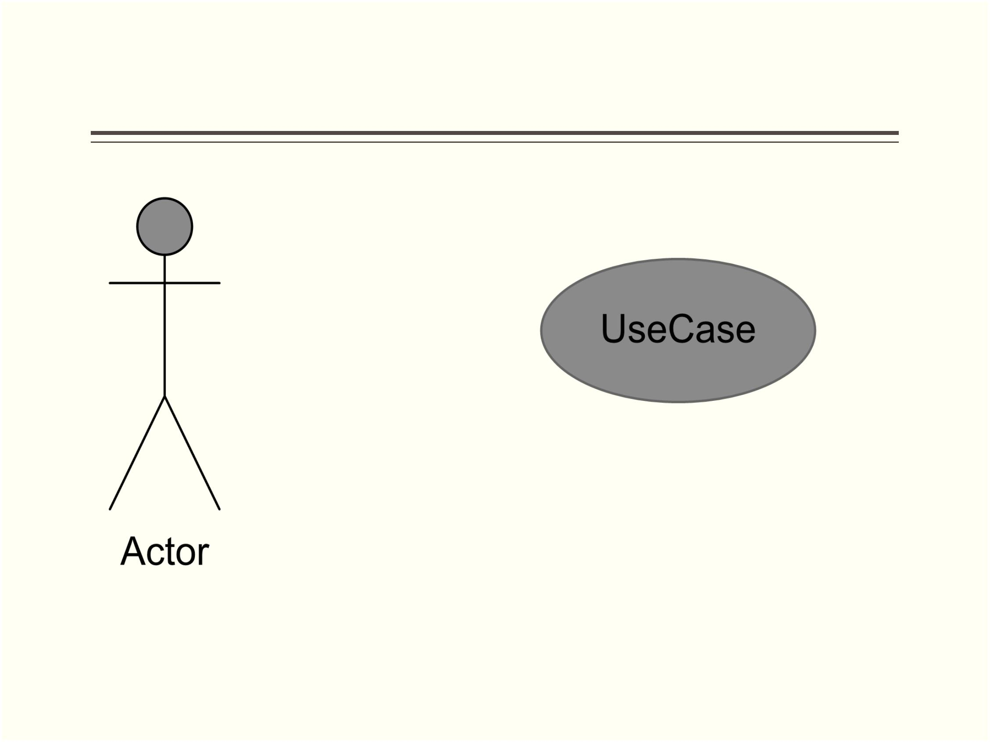

**How to Draw Use Cases Diagrams?**

.

Use cases are a relatively easy UML diagram to draw, but this is

a very simplified example. This example is only meant as an

introduction to the UML and use cases.

.

Start by listing a sequence of steps a user might take in order to

complete an action. For example a user placing an order with a

book seller company might follow these steps.

.

.

.

.

.

.

Browse catalog and select book.

Call sales representative.

Supply shipping information.

Supply payment information.

Receive conformation number from salesperson.

These steps would generate this simple use case diagram

Shree M. & N. Virani Science College (Autonomous)

ATMIYA Group of Institutions, Yogidham Gurukul, Rajkot.

Priyank Doshi

Asst. Professor (MCA, MSc.(Math) )



Shree M. & N. Virani Science College (Autonomous)

ATMIYA Group of Institutions, Yogidham Gurukul, Rajkot.

Priyank Doshi

Asst. Professor (MCA, MSc.(Math) )

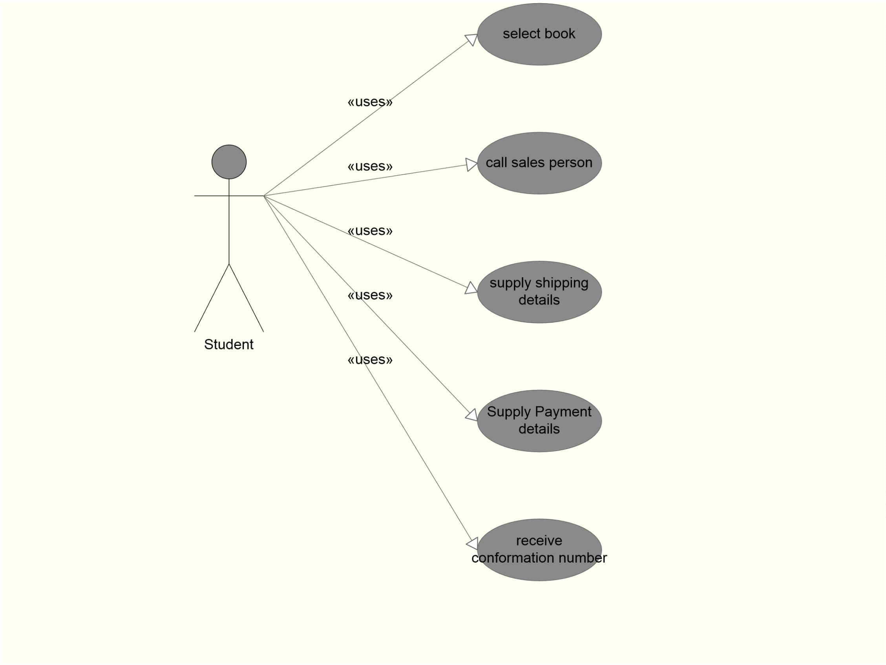

**When to Use ‘’Use Case” Diagrams?**

.

Use cases are used in almost every project. These are helpful

in enlightening requirements and planning the project. During

the initial stage of a project most use cases should be defined,

but as the project continues more might become visible.

Shree M. & N. Virani Science College (Autonomous)

ATMIYA Group of Institutions, Yogidham Gurukul, Rajkot.

Priyank Doshi

Asst. Professor (MCA, MSc.(Math) )



Activity Diagram

.

The main reason to use activity diagrams is to form the workflow

behind the system being designed. Activity Diagrams are also

useful for analyzing a use case by describing what actions need

to take place and when they should occur, describing a

complicated sequential algorithm and modeling applications with

parallel processes.

.

However, activity diagrams should not take the place

of interaction diagrams and state diagrams. Activity diagrams

do not give detail about how objects behave or how objects

collaborate.

Shree M. & N. Virani Science College (Autonomous)

ATMIYA Group of Institutions, Yogidham Gurukul, Rajkot.

Priyank Doshi

Asst. Professor (MCA, MSc.(Math) )



Shree M. & N. Virani Science College (Autonomous)

ATMIYA Group of Institutions, Yogidham Gurukul, Rajkot.

Priyank Doshi

Asst. Professor (MCA, MSc.(Math) )

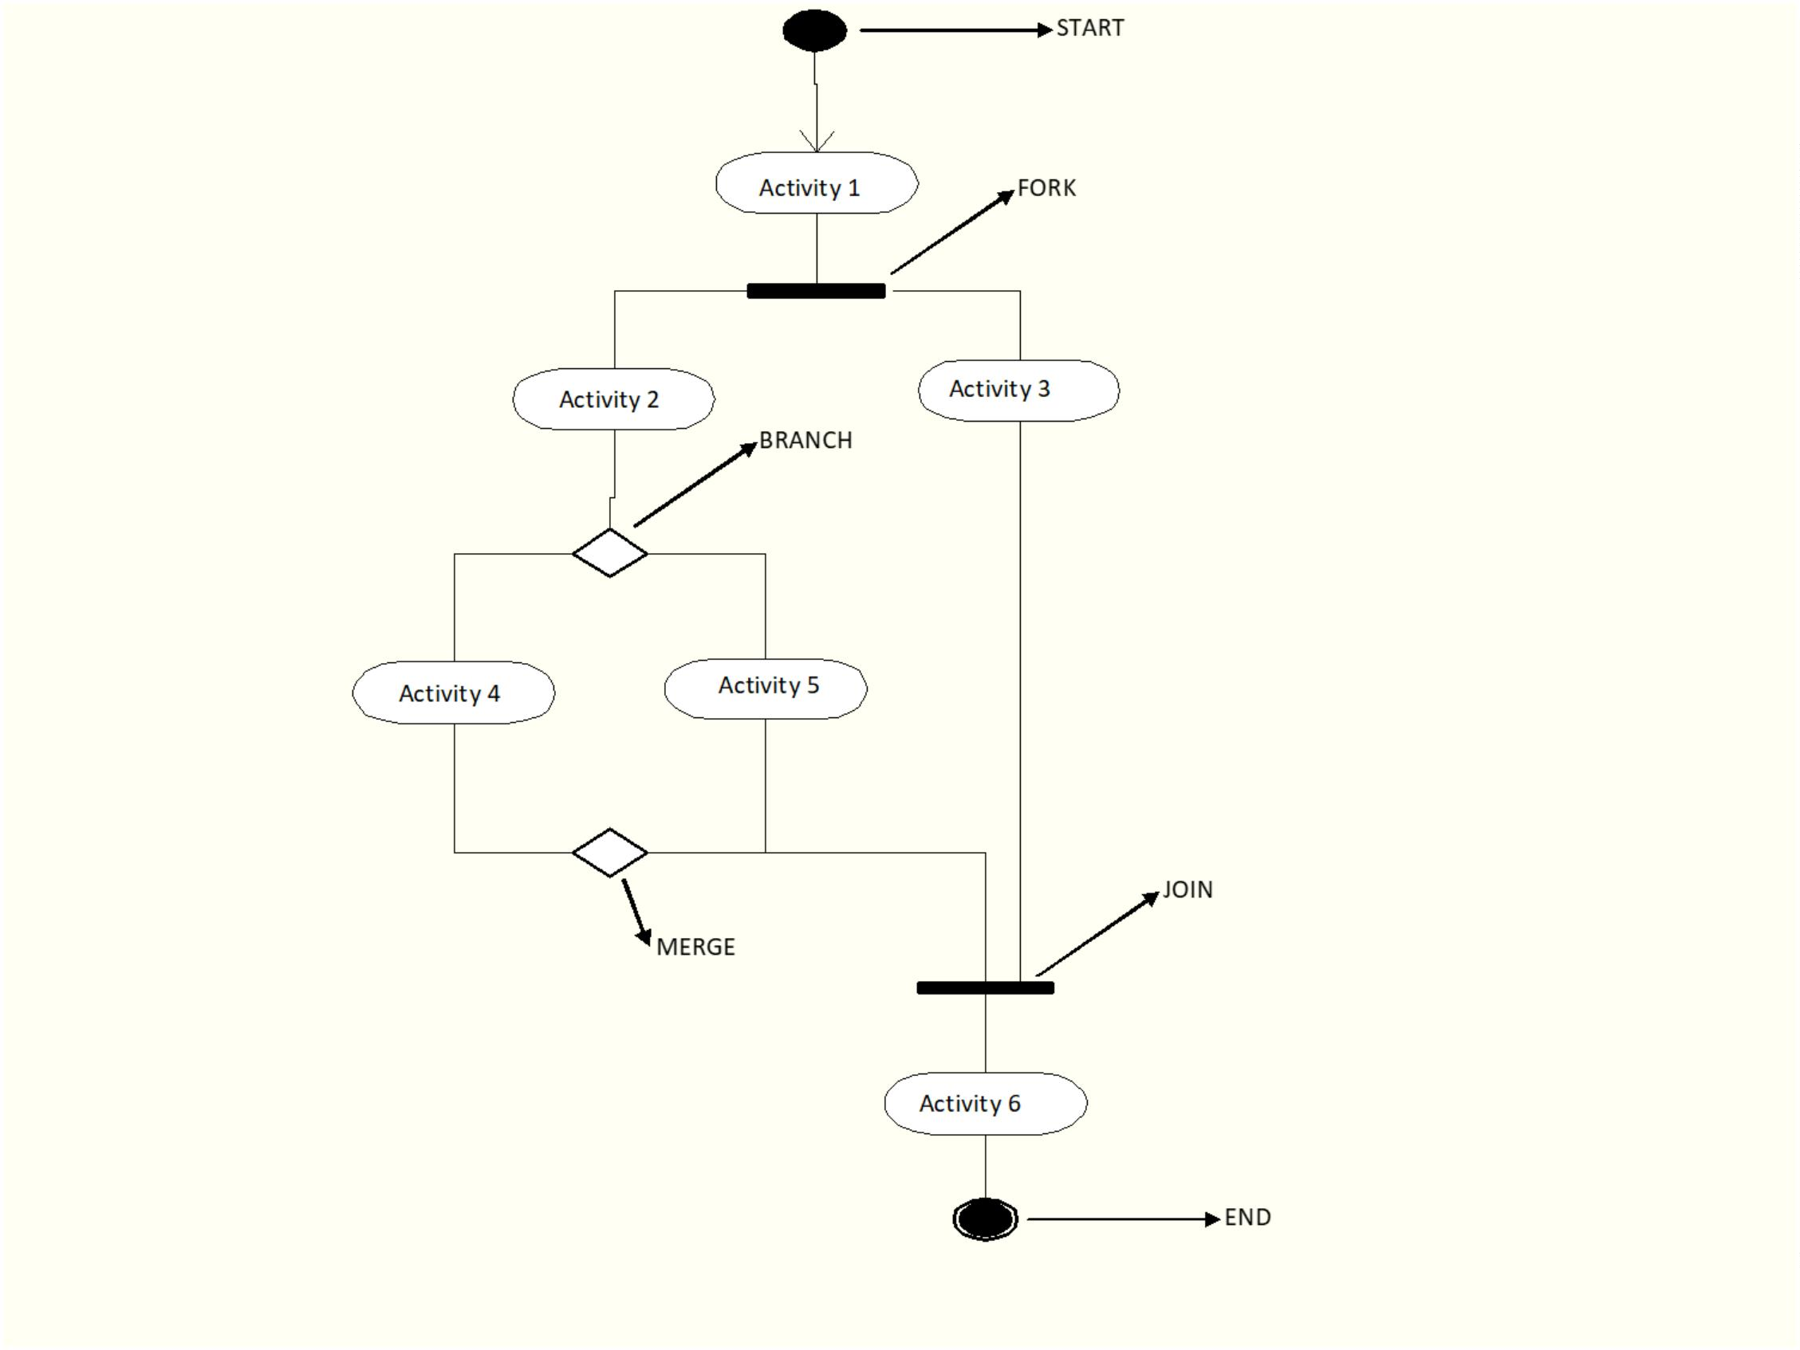

Receive Order

Send Billing Info

Record Order

Cash & Carry

from Shop

Hom e Delivery

Close Order

Shree M. & N. Virani Science College (Autonomous)

ATMIYA Group of Institutions, Yogidham Gurukul, Rajkot.

Priyank Doshi

Asst. Professor (MCA, MSc.(Math) )

